Newsfeed Analysis in Tableau Project Report

# Least liked post subtype

Regarding average likes per post, Collection and Level post subtypes are the least favored.

After examining all subtypes using the ‘Post Subtype’ dashboard filter, it's evident that the Level-type and Collection-type posts are the least popular. This observation is supported by the graph showing monthly average likes and the ratio of likes to the total number of posts.

* + Collection: Out of 9,376 posts 170 received likes
  + Level: Out of 22,313 posts, 422 received likes.

The notably low average of around 0.02 likes per post for both categories underscores this conclusion.

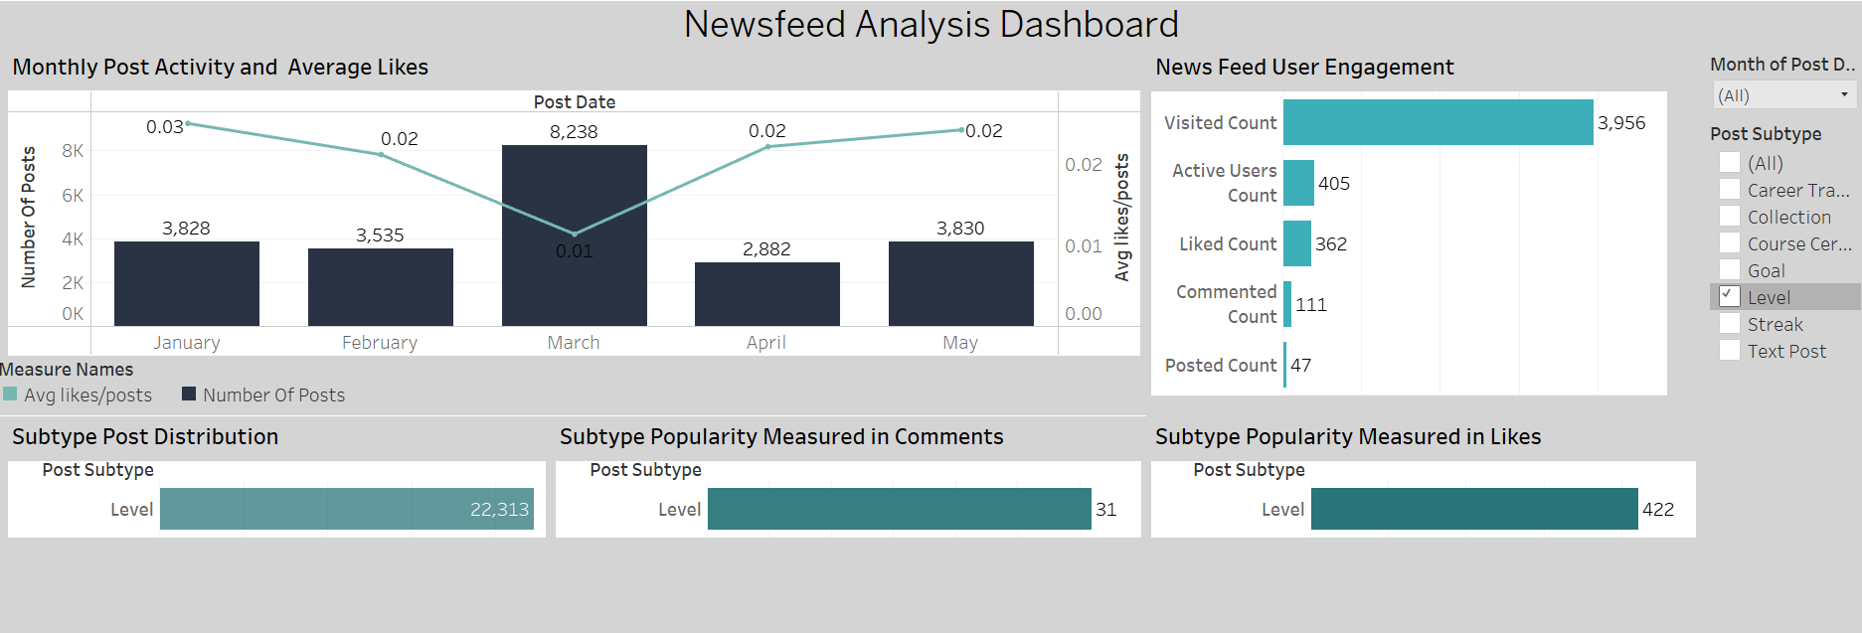

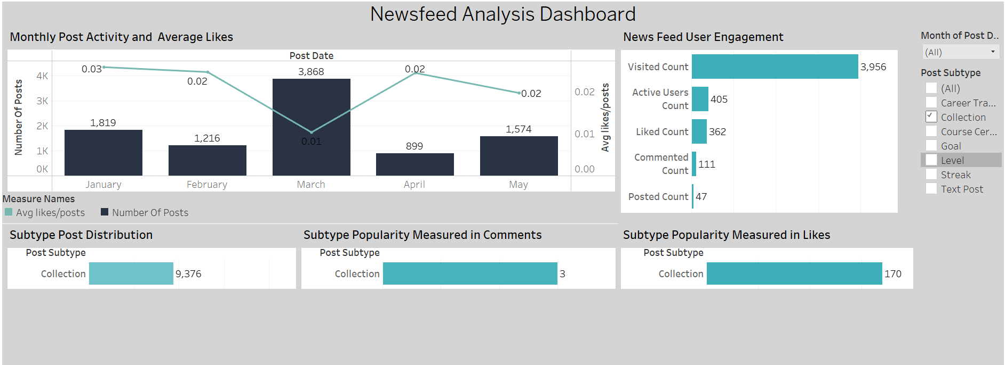

# Post subtype distribution

Consulting the Subtype Post Distribution graph to determine the most and least frequent post types. This visualization indicates that the Level-type posts are the most prevalent, appearing 22,313 times, whereas the Career Track Certificate posts are the least frequent, with only 144 instances. The count is comparable to the second least common post subtype—the manual Text post, with 150 examples

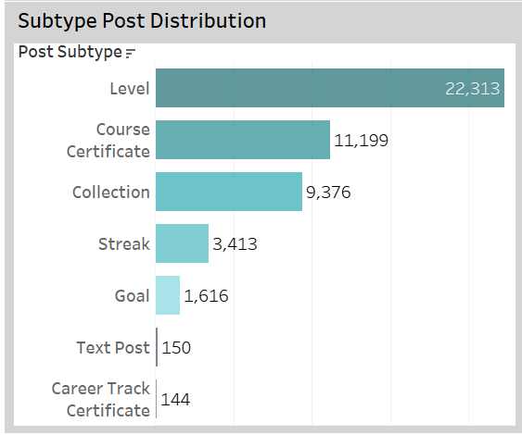

# Amount of active users

Referring to the Newsfeed User Engagement graph to determine the proportion of visitors who engaged with the newsfeed. By dividing the number of active users by the overall visitors and multiplying by 100, we get the engagement rate in percentage. Using this formula, 405 divided by 3956 yields an engagement rate of 10%.

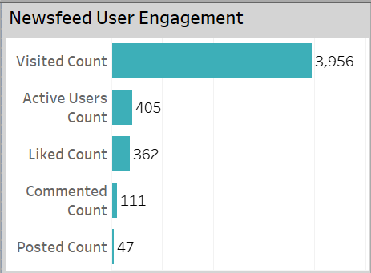

# Recommendations

Based on my observations, Level-type posts dominate the newsfeed, surpassing all other subtypes. Their total count is twice that of the runner-up, the Course Certificate post. Despite their frequency, the trend indicates that Level-type posts—alongside the Collection post subtype—generate minimal interest and seldom entice users to engage with likes.

This suggests that Level-type posts might be saturating the newsfeed with content users don't find compelling, thereby diminishing their overall experience with the feature. A wise strategy might be to reevaluate how these posts are generated and curtail their prevalence on the newsfeed. More engaging posts can take the forefront, potentially elevating user engagement and bolstering interest in the feature—ensuring more captivating posts remain visible rather than those with fewer likes.